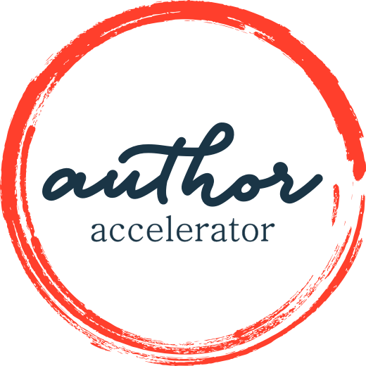
Blueprint for a Book: Nonfiction and Self-Help/Memoir
WORKBOOK

The 2022 Summer Blueprint + Butt In Chair Challenge
Week 1
Write one page about why you want to write this book. Consider external motivators such as money and the admiration of colleagues, and internal motivators such as anger, jealousy, or wanting to prove to yourself (or someone else) that you can really do this.
Be honest with yourself. Knowing your why can fuel your fire to keep writing, especially when the going gets tough (and it will get tough!).
Remember to submit your work here by Thursday, July 7, at 11:59pm PT.
Week 2
Name your point. It may sound like a billboard or a bumper sticker and that’s OK. That’s what you want for this step.
This is a quick assignment, so use the opportunity to revisit your why from Step 1, and to revise your point as many times as you need to until it feels just right. Next week you’ll have more to do.
Remember to submit your work here by Thursday, July 14, at 11:59pm PT.
Week 3
There are several things to do this week, most of which involve spending some time in a bookstore. You’re welcome!
- Find a working title for your book.
- Name your category – where the book will sit on the bookstore shelf.
- Find at least two comp titles that help put your book into context.
- Write one paragraph about your ideal reader – not just the demographics that define them, but what they feel and need.
Remember to submit your work here by Thursday, July 21, at 11:59pm PT.
Week 4
Write jacket copy for your book. Study the jacket copy of the comp titles you found in Step 3 to get a feel for how it should sound. Make it no more than 250 words.
Remember to submit your work here by Thursday, July 28, at 11:59pm PT.
Week 5
Define the arc of change – the transformation journey – for your reader.
- What do they know or believe or understand when they pick up your book? Be specific.
- What do they know or believe or understand when they finish your book that they didn’t at the start? Be specific.
Remember to submit your work here by Thursday, Aug. 4, at 11:59pm PT.
Week 6
Choose a structural prototype. (See the worksheet in this lesson.)
Answer the following questions for the prototype you choose.
Single Narrative
1. What is the main spine of your story? What’s the big idea?
2. What hurdles stand in the way as you try to achieve this goal or as you struggle toward what you are after?
3. What period of time will your story cover?
4. Where will the story start—specifically?
5. Where will it end—specifically?
6. Where are you standing in time when you narrate it?
Collective Narrative
1. What is the main idea of your story? What’s the big idea?
2. What are each of the entries going to be about on a very big-picture level? What, in other words, connects them?
3. How will the pieces be arranged?
4. What are the limits of the scope of this big idea? Are there things you will NOT cover in the book?
5. How many pieces will you include?
6. How will your voice play into the story?
Conceptual Design
- What is the organizing principle?
2. Is there a specific order to the way you present the material, or some kind of logic to the way the materials flows? Are there timelines or steps? Describe the flow of material.
3. What does your table of contents look like?
4. What are the elements of each chapter?
5. Is your own story part of the mix? How much of your own story? How much of the mix?
Remember to submit your work here by Thursday, Aug. 11, at 11:59pm PT.
Week 7
Draft a table of contents. If you already did that in the last step, refine it. Tables of contents can hold the code for an entire book, so don’t just toss it off!
Write two or three sentences to describe each chapter.
Remember to submit your work here by Thursday, Aug. 18, at 11:59pm PT.
Week 8
Create your Outcome Outline (see the worksheet in the lesson). Arrange it so that it starts at the top of a page and keep it to three pages total.
Remember to submit your work here by Thursday, Aug. 25, at 11:59pm PT.
Week 9
Use the 7-Point Outcome Outline Checklist (see the worksheet in this lesson) to check that your Outcome Outline is meeting all the requirements. If you find things that don’t hold together, that’s your clue about what you need to revise. Keep revising the Outcome Outline until it’s as solid as possible.
Remember to submit your work here by Thursday, Sept. 1, at 11:59pm PT.
Week 10 – Final Submission
Revise everything! Go back through all the steps and make them as solid as you can. Try to think about your reader, the transformation they seek, and the outcome you are going to bring them to.
Submit your complete workbook here by Thursday, Sept. 8, at 11:59pm PT. If you have any trouble, reach out to us at contact@authoraccelerator.com.
Want to know whether you’re on the right track with your Blueprint?
Sign up for the Make a Commitment package by Sept. 8!
SIGN UP NOW

