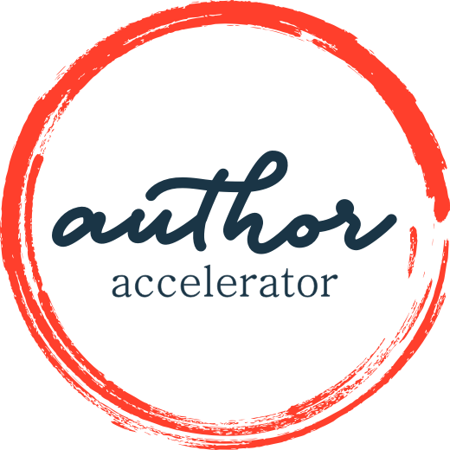
Blueprint for a Book: Fiction and Narrative Memoir
WORKBOOK

The 2022 Summer Blueprint + Butt In Chair Challenge
Week 1
Write one page about why you want to write this book. Consider external motivators such as money and the admiration of colleagues, and internal motivators such as anger, jealousy, or wanting to prove to yourself (or someone else) that you can really do this.
Be honest with yourself. Knowing your why can fuel your fire to keep writing, especially when the going gets tough (and it will get tough!).
Remember to submit your work here by Thursday, July 7, at 11:59pm PT.
Week 2
Name your point. It may sound like a billboard or a bumper sticker and that’s OK. That’s what you want for this step.
This is a quick assignment, so use the opportunity to revisit your why from Step 1, and to revise your point as many times as you need to until it feels just right. Next week you’ll have more to do.
Remember to submit your work here by Thursday, July 14, at 11:59pm PT.
Week 3
There are several things to do this week, most of which involve spending some time in a bookstore. You’re welcome!
- Find a working title for your book.

- Name your genre (fiction) or category (for memoir).
- Find at least two comp titles that help put your book into context.
- Write one paragraph about your ideal reader – not just the demographics that define them, but what they feel and need.
Remember to submit your work here by Thursday, July 21, at 11:59pm PT.
Week 4
Write jacket copy for your book. Study the jacket copy of the comp titles you found in Step 3 to get a feel for how it should sound. Make it no more than 250 words.
Remember to submit your work here by Thursday, July 28, at 11:59pm PT.
Week 5
Answer the following questions:
- Who is your protagonist? (If you’re writing memoir, your protagonist is you.) What do they want at the start of the story?
- What is their arc of change – their transformation journey? What do they know or believe or understand at the end of the story that they didn’t at the start? How are they different?
- What stands in the way of the protagonist getting what they want, externally and internally?
- Are they telling the tale, or is the narrator someone other than the protagonist?
- Will there be other POV characters?
Remember to submit your work here by Thursday, Aug. 4, at 11:59pm PT.
Week 6
Answer the following questions:
- Where is the narrator standing in time?
- What period of time does the book cover?
- Where does the book start and end?
- Does the reader know things the protagonist does not, and if so, how? (This is a good chance to check to make sure that your POV serves your story.)
Remember to submit your work here by Thursday, Aug. 11, at 11:59pm PT.
Week 7
Create a “Because of that” story summary.
Once upon a time there was _______________.
Every day ______. One day _______.
Because of that ______.
Because of that ______.
Until finally _______.
And ever since that day __________.
Remember to submit your work here by Thursday, Aug. 18, at 11:59pm PT.
Week 8
Create your Inside Outline (see the worksheet in the lesson).
- Use standard manuscript formatting: 12-pt. single-spaced Times New Roman font, with 1-inch margins and one full line space between the bullet-point pairings.
- Write no more than 3 pages. To make this simple to track, start your Inside Outline at the top of a new page in this workbook.
- Each bullet point should have no more than 3 lines.
- Each scene must cause the next one so that your story has narrative drive.
Remember to submit your work here by Thursday, Aug. 25, at 11:59pm PT.
Week 9
Use the 10-Point Inside Outline Checklist (see the worksheet in the lesson) to check that your Inside Outline is meeting all the story requirements. If you find things that don’t hold together, that’s your clue about what you need to revise. Keep revising your Inside Outline until it’s as solid as possible.
Remember to submit your work here by Thursday, Sept. 1, at 11:59pm PT.
Week 10 – Final Submission
Revise everything! Go back through all the steps and make them as solid as you can. Try to think about your reader, the logic of your plot, and the emotional arc of the story.
Submit your complete workbook here by Thursday, Sept. 8, at 11:59pm PT. If you have any trouble, reach out to us at contact@authoraccelerator.com.
Want to know whether you’re on the right track with your Blueprint?
Sign up for the Make a Commitment package by Sept. 8!
SIGN UP NOW

