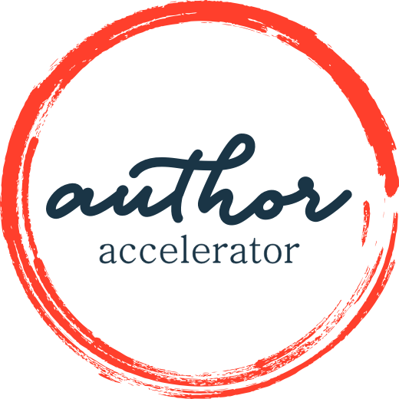
Three Nonfiction Prototypes
WORKSHEET

Excerpted from Blueprint for a Nonfiction Book: Plan and Pitch Your Big Idea by Jennie Nash
The structure of a book refers to the overall shape or form of the idea—how it is organized, how it functions. It is bigger than the outline of the book or a list of its contents (which we will get to in a moment). The structure you select has a profound impact on how your reader will experience the material and what they will take away from it.
Let’s look at the three basic structures for nonfiction books. There are, of course, far more than just three, but we’ll focus on these to simplify things. As I describe each one, try to imagine your material taking the shape I am describing. Is it a natural fit? Or is it like putting a square peg into a round hole? If the latter, that’s a red flag. You need to make sure your structure serves your material.
This way of looking at your book is taking a mile-high view. It’s not the table of contents—that comes next. If you were building a house, you would be deciding what kind of house—sprawling ranch house for a big family or small bungalow for a newlywed couple—not laying out the rooms and certainly not picking out tile and paint color.
- Single Narrative
This way of writing a book tells one story, from beginning to end, in a roughly chronological narrative format. I say roughly, because chronologies can be fractured, or presented out of order, but those are stylistic choices. The basic structure of the book is still a single narrative. These kinds of stories can either be memoir (the author’s own story), reported stories about another individual, or reported stories about a situation, entity, event, or group of people.
The “single” in the title of this structural prototype refers to the fact that the narrative is
focused on one single story. The Premonition by Michael Lewis, for example, chronicles a group of scientists and public health professionals who were working on a plan for controlling a pandemic before the pandemic; their stories are woven together and make up the threads of the single narrative about the U.S. public health system and contagion.
Examples of memoir include:
Eat, Pray, Love by Elizabeth Gilbert – a memoir of one woman’s journey around the world to find herself.
Maybe You Should Talk to Someone by Lori Gottlieb – a memoir of a therapist who goes into therapy.
A Three Dog Life by Abigail Thomas – a fractured narrative about a woman whose husband suffers from a brain injury.
Examples of reported stories about an individual include:
The Immortal Life of Henrietta Lacks by Rebecca Skloot – a journalist investigates what happened to the cells of Henrietta Lacks when they were used for research.
Midnight in the Garden of Good and Evil by John Berendt – a reporter covers a murder trial in Savannah, Georgia.
Examples of reported stories about a situation, entity, event, or group of people include:
Into Thin Air by Jon Krakauer – the story of an ill-fated Mt. Everest expedition.
The Premonition by Michael Lewis – an exploration of the individuals who knew the pandemic was coming and tried to stop it.
She Said by Jodi Kantor and Megan Twohey – a behind-the-scenes story of the two New York Times journalists who broke the Harvey Weinstein scandal.
- Collective Narrative
This way of writing a book presents a collection of narratives about one topic. The author does not make an effort to weave the stories into one cohesive whole the way they might when writing a single narrative; they are curating different voices or different interviews and putting them in a specific order. One of the included stories may be the author’s own story.
Examples include:
Tribe of Mentors: Short Life Advice from the Best in the World by Timothy Ferriss – a compilation of advice from 130 of the world’s top performers.
Moms Don’t Have Time To: A Quarantine Anthology by Zibby Owens – essays from a variety of parents and writers about living through the pandemic.
Cherished by Barbara Abercrombie – stories about cherished pets from a variety of writers, including the author.
- Conceptual Design
In these kinds of books, the concept or topic you are writing about drives the organization. You are teaching your readers something through a proven framework, and you are likely including primary research, observations, or experiences to support your point. The structure is designed to explain that framework or concept.
Examples include:
Bird by Bird by Anne Lamott – Lamott shares stories about the writing life and teaches distinct lessons along the way. The stories are selected and placed to illustrate the lessons. Much of this book feels like memoir because Lamott shares stories from her life, but the intent of the book is very explicit: to teach the reader how to live the writing life. It is, therefore, shelved in bookstores in the writing reference section, not the memoir section.
The 4-Hour Workweek by Timothy Ferriss – A book about how to work less and earn more.
Made to Stick by Chip Heath and Dan Heath – A book about how to craft a message to help your business attract sales and buzz.
Freakonomics by Steven D. Levitt and Stephen J. Dubner – an economist presents a rogue theory about economic incentive.
Quiet by Susan Cain – a book about being an introvert in a noisy world.
The Life-Changing Magic of Tidying Up by Marie Kondo – a theory for cleaning house based on the concept of joy.
Colleges that Change Lives by Loren Pope – a list of 40 colleges that will change the way you think of college.
1,000 Places to See Before You Die by Patricia Schultz – a collection of awe-inspiring travel spots.
The Barefoot Contessa Cookbook by Ina Garten – a collection of delicious recipes.
Don’t Sweat the Small Stuff by Richard Carlson – a collection of tips, insights, and inspiration for stress-free living.
Take Action
Answer the following questions for the prototype you choose.
Single Narrative
- What is the main spine of your story? What’s the big idea?
- What hurdles stand in the way as you try to achieve this goal or as you struggle toward what you are after?
- What period of time will your story cover?
- Where will the story start—specifically?
- Where will it end—specifically?
- Where are you standing in time when you narrate it?
Collective Narrative
- What is the main idea of your story? What’s the big idea?
- What are each of the entries going to be about on a very big-picture level? What, in other words, connects them?
- How will the pieces be arranged?
- What are the limits of the scope of this big idea? Are there things you will NOT cover in the book?
- How many pieces will you include?
- How will your voice play into the story?
Conceptual Design
- What is the organizing principle?
- Is there a specific order to the way you present the material, or some kind of logic to the way the materials flows? Are there timelines or steps? Describe the flow of material.
- What does your table of contents look like?
- What are the elements of each chapter?
- Is your own story part of the mix? How much of your own story? How much of the mix?

